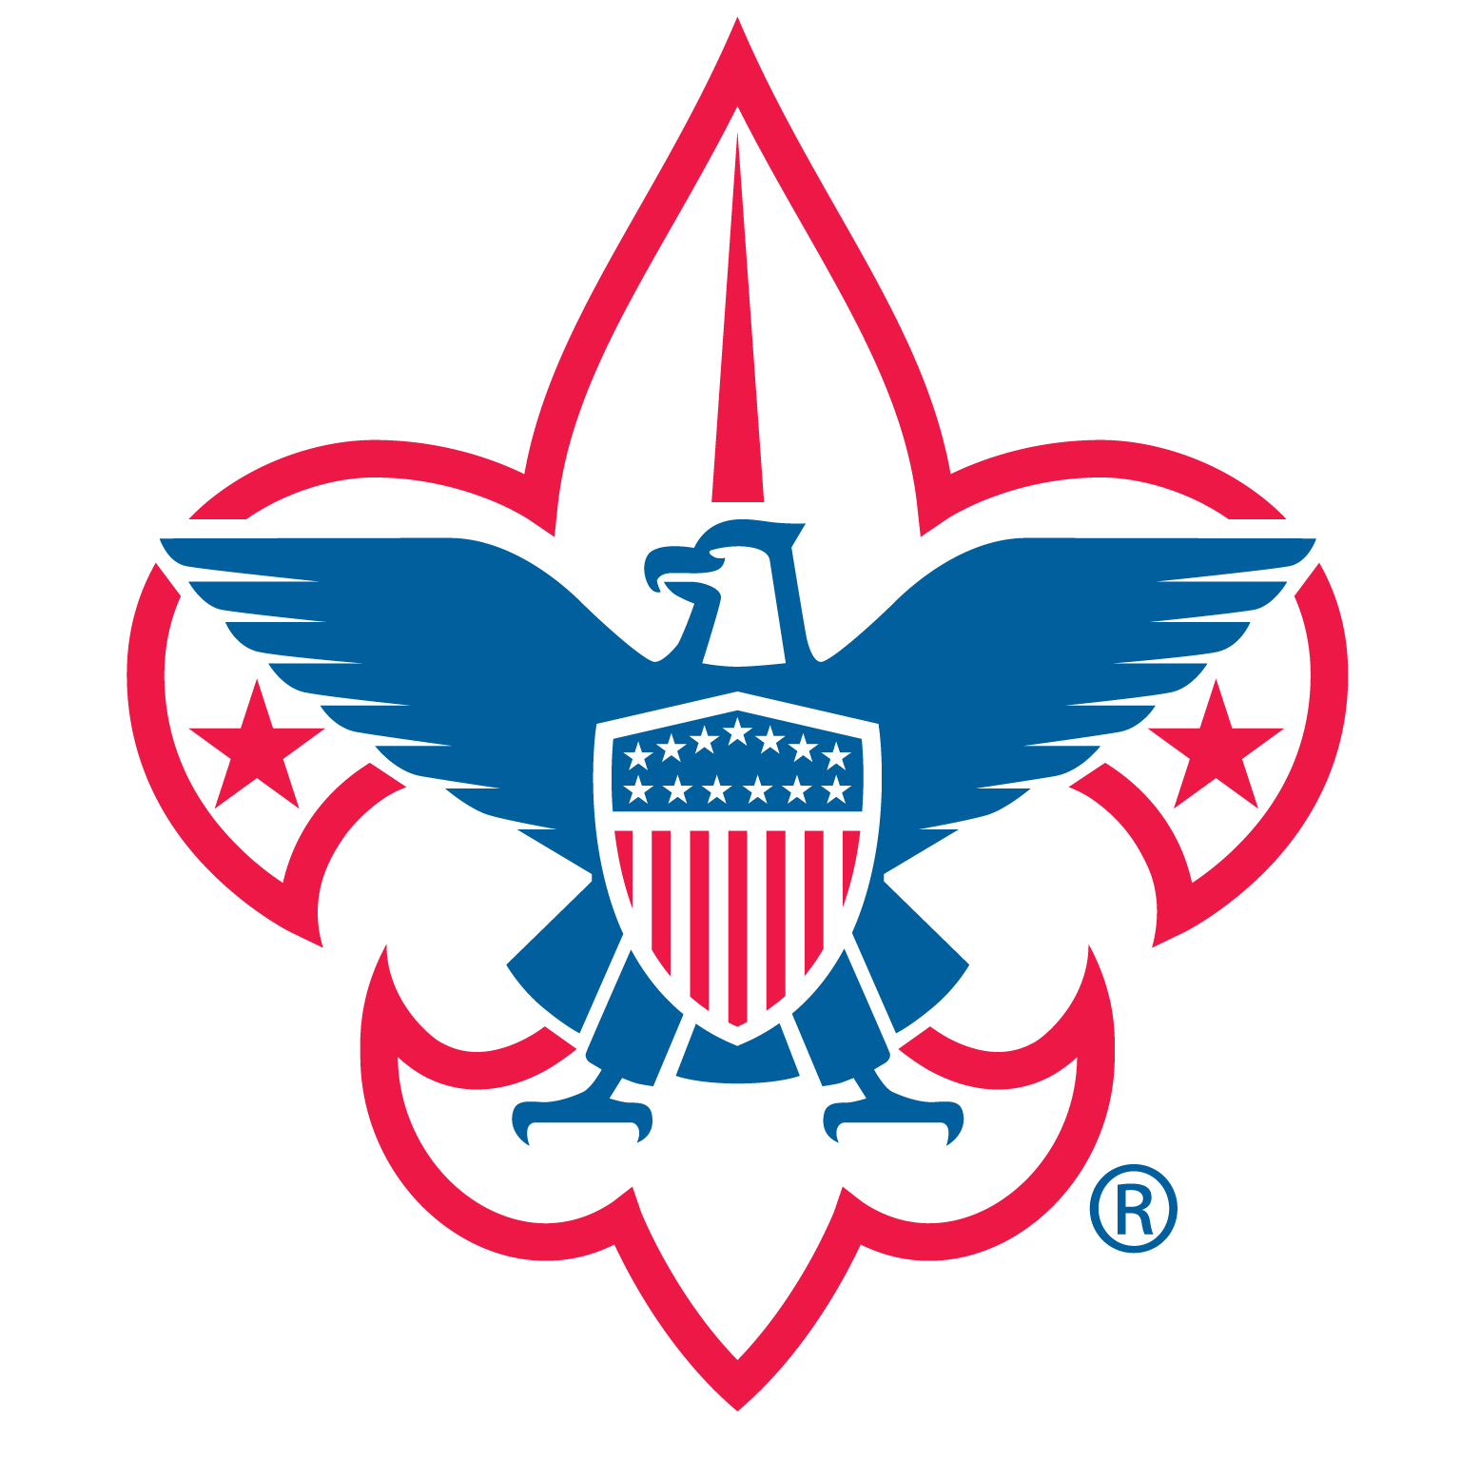
Outing Planner
Troop 418 – Hilliard, Ohio

- Description __________________________________________________________________

- Location ____________________________________________________________________

- Departure Date and Time _______________________________________________________
  - Registration/Pack Troop Gear Time AND Departure Time.
  - Departure Location, Address (i.e. Hilliard Presbyterian Church).
______________________________________________________________________
- Return Date and Time __________________________________________________________
  - Return Location, Address (i.e. HPC, Eye Center)
______________________________________________________________________

- Youth Leader in Charge _________________________________________________________

- Adult Leader in Charge _________________________________________________________

- Expected attendance (Scouts) _____________________

- Expected attendance (adults) _____________________

Three Months Out
- Review The Outdoor Program – Chapter 9 – Troop Leader Guidebook (ask Outdoor/Activities Chair for copy).
- Review Specific Program Section - i.e. camping, backpacking trek - Program Features for Troops, Teams, and Crews: A Guide to Program Planning (Ask Outdoor/Activities Chair for copy).
- Assign youth and adult coordinators.
- Confirm dates and times.
- Reserve campsite.
- Recruit program specialists (e.g. certified COPE instructor).
- See if specific training is required (see One Month Out).
- Set placeholder in Troop Calendar – Scout Track.

Two Months Out
- Plan the budget; set the price if known - Budget Worksheet. Can determine price after campout.
- Submit required forms (e.g., campsite reservation, fishing and boating licenses).
- Begin promotion.
  - Set up registration event in Sign Up Genius – Contact Sign Up Genius Coordinator.
  - Announce at Scout Meeting.
  - Send email through Scout Track to troop. Include the following:
    - Description/Flyer/Trip Plan.
    - Date and Location.
    - Departure and Arrival Information.
    - Registration link to Sign Up Genius.
    - Due date for registration.
    - Cost if known.
    - Adult Leader in Charge – Contact Information for Questions
    - Age Restrictions if any.
    - Training Requirements if any.
    - Ask for drivers.
    - What to Bring List – Personal Gear (Link to Troop Website – Forms).
    - BSA Permission Slip (Link to Troop Website – Forms).
    - BSA Annual Medical Form – if new scout or expired (Link to Troop Website – Forms).
- Plan special training or shakedowns, including those required by outfitters.
- Begin recruiting adult leaders and drivers.

One Month Out
- Develop Tour and Activity Plan, including a schedule.
  - As of now, Scoutmaster submits to Council. Coordinate with Scoutmaster & Outdoor/Activities Chair.
  - This is a good tool to use to insure you are covering the bases. Not required for all campouts, but required for some. Read Tour and Activity Plan FAQs – good to know.
  - See online version through Simon Kenton Council website or scouting.org – click tools. Paper handout is also available.
- Collect any missing Annual Health and Medical Record forms.
- Begin teaching needed skills at troop meetings.
- Ensure at least one leader has training in basic first aid (wilderness first aid for backcountry trips), hazardous weather, and – depending on the activity – Safe Swim Defense, Safety Afloat, and/or Climb on Safely.
- Complete and submit a Tour and Activity Plan to Council – at least 21 days before event.
  - Scoutmaster Performs this Task as of now. Coordinate with Scoutmaster.
  - See online version through Simon Kenton Council website or scouting.org – click tools. Paper handout is also available.
- Continue promotion.
  - Check registration event in Sign Up Genius.
  - Announce at Scout Meeting.
  - Send email through Scout Track. Include the following:
    - Description/Flyer/Trip Plan.
    - Date and Location.
    - Departure and Arrival Information.
    - Registration link to Sign Up Genius.
    - Due date for registration.
    - Cost if known.
    - Adult Leader in Charge – Contact Information for Questions.
    - Age Restrictions if any.
    - Training Requirements if any.
    - Ask for drivers.
    - What to Bring List – Personal Gear (Link to Troop Website – Forms).
    - BSA Permission Slip (Link to Troop Website – Forms).
    - BSA Annual Medical Form – if new scout or expired (Link to Troop Website – Forms).
- Secure any special troop and patrol equipment (e.g., canoes, climbing gear).

Three Weeks Out
- Promote at Meeting.
- Have paper Sign Up Sheet at Meeting.

Two Weeks Out
- Send email through Scout Track. Include links to all necessary forms – see above.
- Make sure you have enough drivers and enough gear haulers.
- Check the route and prepare maps as needed.
- Confirm the location of rest stops on long trips. (Groups should not travel in tight convoys.)
- Confirm the nearest medical facility and emergency phone number.
- Confirm the campsite contact and phone number.
- Prepare rainy-day activities.
- Promote at Meeting.
  - Promote Sign Up Sheet.
- Have patrols assign grub maters and plan menus, shopping duties, and duty rosters.
  - Use Patrol Method Duty Roster – Scout Leader Prepare.
  - See Patrol Menu Planner – Assign Scouts working on rank advancement & Cooking Merit Badge.

One Week Out
- Send email about final details through Scout Track. Include links to all necessary forms - see above.
- Confirm Scout and adult attendance.
  - Crosscheck with paper Sign Up Sheet and Sign up Genius.
- Collect permission slips – Can be Day of Outing.
- Confirm the campsite reservation.
- Confirm the participation of program specialists.
- Have patrols assign grub maters and plan menus, shopping duties, and duty rosters.
  - Use Patrol Method Duty Roster – Scout Leader Prepare.
  - See Patrol Menu Planner – Assign Scouts working on rank advancement & Cooking Merit Badge.
- Assemble troop and patrol equipment.
  - See Troop and Patrol Gear Planner.
- Do a personal gear shakedown, if necessary.
- Check the weather forecast.
- Announce the departure and arrival times, if not already announced.

Day of Outing
- Collect Signed BSA Permission Slip.
- Collect BSA Medical Forms (if not on file or up to date).
- Distribute emergency contact information to parents.
- Do a final gear and food check.
  - See Troop and Patrol Gear Planner.
  - See Patrol Menu Planner.
- Pack Vehicles – Trailer – Insure two deep leadership in vehicles.
- Give maps of route to drivers.
- Share travel plans with someone who is staying behind.
- Leave on time, have fun, and be safe.

During Outing
- Register On-site.
- Set up camp. Scout Leader Implement While Setting Up Camp Checklist. Duty Roster.
- Scout Leader Prepares and Implements Duty Roster – See Patrol Method Duty Roster.
- Maintain orderly campsite during outing – See During the Campout.
- Break up camp. See While Setting Up Camp Checklist (While Breaking Camp).

After the Outing
- Call parents for pickup after arrival, if needed.
- Unpack vehicles and trailer.
- Ensure proper storage of equipment.
  - Dry out tents and pack away.
  - Inspect equipment.
  - Repair equipment.
  - Report needed equipment, replacements, and updates to Quartermaster & Equipment Chair
- Submit the following to Treasurer.
  - Receipts.
  - Outstanding costs.
  - List of participants.
  - Cost per participants.
  - Submit participant list.
- Evaluate program with Outdoor/Activities Chair.

Resources:
- Boy Scout Handbook
- Boy Scout Fieldbook
- Troop Leader Guidebook – The Outdoor Program – Chapter 9
- Program Features for Troops, Teams, and Crews: A Guide to Program Planning
- Troop Calendar – Scout Track
- Budget Worksheet
- Sign Up Genius
- What to Bring List – Personal Gear
- BSA Permission Slip
- BSA Medical Form
- Tour and Activity Plan
- Patrol Method Duty Roster
- Patrol Menu Planner
- Troop and Patrol Gear Planner
- While Setting Up Camp Checklist
- During the Campout

Sign Up Genius - Send information to Troop Sign Up Genius Coordinator who will set up a sign up event and create a link. The Sign Up Coordinator will send the link to you (adult leader in charge). Use this link in all event promotion emails to the troop.
Scout Track – You should have rights to send emails to all members of the troop: adults and scouts. If there are any questions related to Scout Track. Contact the troop Scout Track Coordinator.

